Site/Location: |  | Prepared by:
Job Description : |  | Date Prepared:
1. STOP AND LOOK
2. THINK THROUGH THE TASK or na Comments/Controls
Correct tools?
Equipment locked out?
Prestart checks done?
Nearby equipment/personnel/systems affected?
Is there a procedure for this task?
Am I competent to perform the task?
Enough information to do the task?
Do I have safe access/egress?
Is there an alternative safer method?
Enough people to perform the task?
3. IDENTIFY THE HAZARD (record details on reverse side)
Highest risk level (eg 12 – moderate, see backside)
Is a JHA required?
If you identify a changed/new hazard with a controlled risk level greater than Low then a JHA or SWMS will be required (risk scoring to be done using likelihood X consequence table on backside (& WNH Q14).
4. CONTROL & COMMUNICATE
Hazards eliminated or controlled?
Potential problems discussed?
5. DO THE JOB SAFELY
Can this job continue safely?
Continually monitor for changes & new hazards

Further comments or controls (dot points/key words is fine).
Hazard | Control

Controlled Risk Action Table
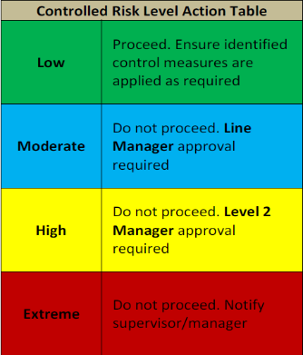
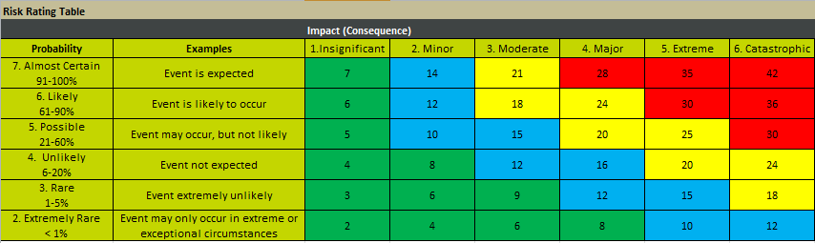
Risk Rating Table

