Site/Location: |  |  |  |  | Permit to Work or Contract No.
Job Description: |  |  |  |  | Date Prepared:
Prepared by: |  | Person In Charge: |  |  | Project or job no.
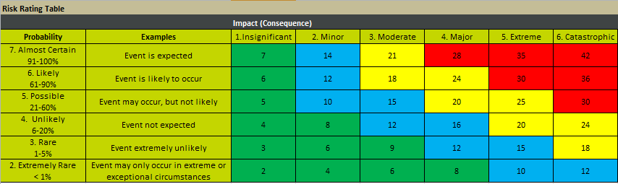 |  |  |  | Other PPE Required (Please Describe) -
   | Mandatory PPE (unless otherwise specified in JHA)
   |  | 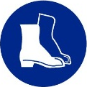 | 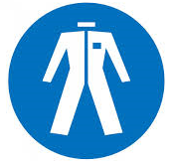
   | Additional PPE Required (May be required for specific tasks/work areas)
  ☐  |  | ☐  | ☐ 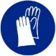 | ☐  | ☐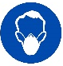
 | Health and Safety | Natural Environment | 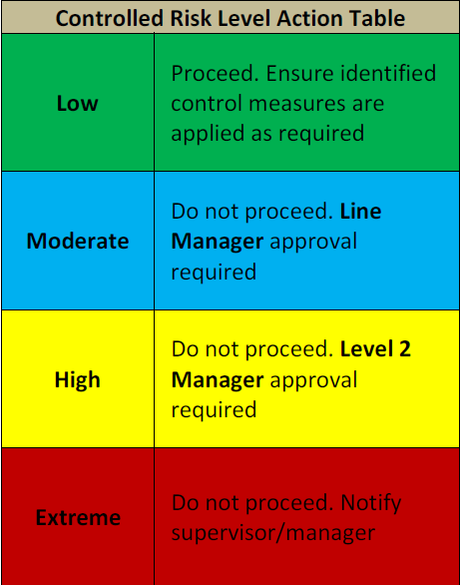  Social and Cultural Heritage
Catastrophic | One or more fatalities. Injury, illness or disease resulting in deaths. | Serious environmental harm causing a significant impact on regional ecosystem with eventual recovery impossible. | Irreversible damage to heritage values, significant aboriginal relics and protected sites.
Extreme | Severe injury, permanent disability to one or more persons. | Serious environmental harm. Eventual recovery of ecological systems, but not necessarily to the same pre-incident conditions. | Core change in the aesthetic or heritage values, significant aboriginal relics and protected sites.
Major | Severe injury, temporary disability. | Material environmental harm, large oil loss (> 1000 litres). | Damage to aesthetic or heritage values, significant aboriginal relics and protected sites.
Moderate | Serious injury with anticipated full recovery. | Environmental harm resulting in environmental nuisance or possible environment harm, loss of oil (200 - 1000 Litres). | Damage or disturbance to listed State Heritage listed places, aboriginal relics or protected sites without a permit.
Minor | Medical treatment injury with no long-term impact on health or wellbeing. | Possible environmental harm or an environmental nuisance to land or waterways - spills <200 litres. | Minor damage or disturbance to State Heritage listed places without an exemption, incidental impacts to aboriginal relics.
Insignificant | First-aid treatment. | Negligible or no environmental harm. Possible incidental impact on flora and fauna. Minor spills. | Incidental impacts on non-statutory heritage assets or exempted actions on state-listed places.

Pre-Start Risk Assessment (Use the likelihood and consequence categories and the JHA risk scoring matrix to complete the risk assessment)
Job Steps | Hazard Descriptions | Uncontrolled Risk Level | Control Measures | Controlled Risk Level

Sign-on Sheet (Team Leader responsible for completing the work/task must complete the following pre-start assessment)
Name: |  |  |  |  | Signature:
Does the team have appropriate authorisation and training to implement the controls so that the job can be done SAFELY?  If NO, DO NOT continue with the job until you have the knowledge, competency and equipment. |  |  |  |  |  |  |  |  |  | Yes ☐ No ☐
Are there any moderate or higher controlled risk levels?  YES – Do not start work and notify your manager/supervisor immediately |  |  |  |  |  |  |  |  |  | Yes ☐ No ☐
Provide a brief explanation as to why the controlled risk level is moderate or high:
NO – Start Work. Remember to continually monitor and review the JHA throughout the job and amend whenever necessary.
Acknowledgement (by signing below, I acknowledge that I understand the hazards associated with this work/task and the required controls to work safely)
Team Member Name |  | Signature | Date | Team Member Name |  | Signature |  | Date | Team Member Name |  | Signature | Date

Additional Hazards Identified on Site
Job Steps | Hazard Descriptions | Uncontrolled Risk Level | Control Measures | Controlled Risk Level

Authorisation to proceed with known moderate risk (the approver acknowledges that they understand this risk cannot be reduced further but work can still proceed)
Line Manager Approval: |  | Signature: |  | Date:

Authorisation to proceed with known high risk (Level 2 Manager acknowledges that they understand this risk cannot be reduced further but work can still proceed)
Level 2 Manager Approval : |  | Signature: |  | Date:
A SWMS will be required for the following high risk activities defined in the WHS Regulations:
- Risk of falls from greater than 2 metres;
- work on a telecommunications tower;
- demolition of load-bearing structure;
- likely to involve disturbing asbestos;
- temporary load-bearing support structures;
- work in Confined Spaces;
- work in or near shaft or trench with an excavated depth greater than 1.5m or in a tunnel;
- use of Explosives;
- work on or near pressurised gas pipes or mains;
- work on or near chemical, fuel or refrigerant lines;
- work on or near energised electrical installations or services;
- work in an area with contaminated or flammable atmosphere;
- work with tilt up or pre-cast concrete;
- work on, in or adjacent to road, rail shipping or other major traffic corridor;
- work in an area with movement of powered mobile plant;
- work in or areas with artificial extremes of temperature;
- work in or near water involving a drowning Risk; and
- Diving work; and
- Other tasks identified as high risk through a risk assessment.

