Site/Location: |  |  |  |  | Permit to Work or Contract No.
Job Description: |  |  |  |  | Date Prepared:
Prepared by: |  | Person In Charge: |  |  | Project or job no.
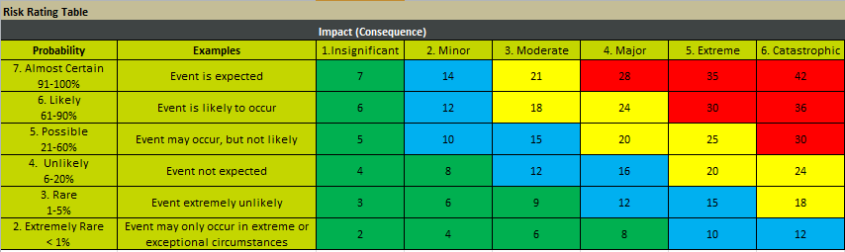 |  |  |  | Other PPE Required (Please Describe) -
   | Mandatory PPE (unless otherwise specified in JHA)
   |  | 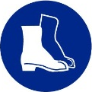 | 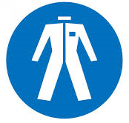
   | Additional PPE Required (May be required for specific tasks/work areas)
  ☐  |  | ☐  | ☐  | ☐  | ☐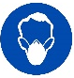
 | Health and Safety | Natural Environment | Annual Budget / Financial Loss
Catastrophic | One or more fatalities.  Injury, illness or disease resulting in deaths. | Serious environmental harm causing a significant impact on regional population or ecosystem with eventual recovery impossible. | 25% over Business approved opex or capex budget  Or  Financial loss > $25M
Extreme | Severe injury, permanent incapacitation to one or more persons. | Serious environmental harm causing concerning impacts to local ecosystem or populations. | 15% over Business approved opex or capex budget  Or  Financial loss >$15M - <$25M
Major | Severe injury, with temporary incapacitation. | Material environmental harm, such as population/ecosystem impact with no residual effects likely after follow up. | 5% over Business approved opex or capex budget  Or  Financial loss $1M - < $15M
Moderate | Serious injury with anticipated full recovery. Lost time <5 working days. | Environmental harm resulting in environmental nuisance or possible material environment harm. | 2% over Business approved opex or capex budget  Or  Financial loss $200k - <$1M
Minor | Medical treatment injury with no long-term impact on health or wellbeing. | Possible environmental harm or an environmental nuisance. | 1% over Business approved opex or capex budget  Or  Financial loss $10k - < $200k
Insignificant | First-aid treatment. | Negligible, or no environmental harm. Possible incidental impact on flora and fauna with minimal to no known consequences. | <1% over Business approved opex or capex budget  Or  Financial loss < 10k
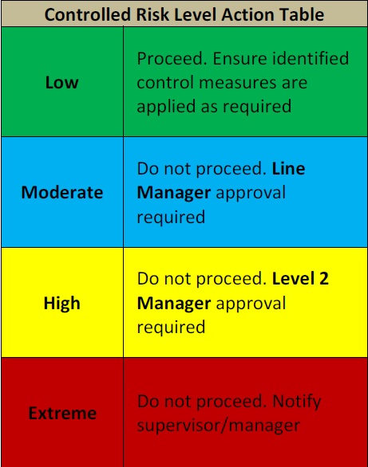
If required refer to full Consequence table in Risk Management Procedure (WNH Q14).

Pre-Start Risk Assessment (Use the likelihood and consequence categories and the JHA risk scoring matrix to complete the risk assessment)
Job Steps | Hazard Descriptions | Uncontrolled Risk Level | Control Measures | Controlled Risk Level
Sign-on Sheet (Team Leader responsible for completing the work/task must complete the following pre-start assessment)
Name: |  |  |  |  | Signature:
Does the team have appropriate authorisation and training to implement the controls so that the job can be done SAFELY?  If NO, DO NOT continue with the job until you have the knowledge, competency and equipment. |  |  |  |  |  |  |  |  |  | Yes ☐ No ☐
Are there any moderate or higher controlled risk levels?  YES – Do not start work and notify your manager/supervisor immediately |  |  |  |  |  |  |  |  |  | Yes ☐ No ☐
Provide a brief explanation as to why the controlled risk level is moderate or high:
NO – Start Work. Remember to continually monitor and review the JHA throughout the job and amend whenever necessary.
Acknowledgement (by signing below, I acknowledge that I understand the hazards associated with this work/task and the required controls to work safely)
Team Member Name |  | Signature | Date | Team Member Name |  | Signature |  | Date | Team Member Name |  | Signature | Date

Additional Hazards Identified on Site
Job Steps | Hazard Descriptions | Uncontrolled Risk Level | Control Measures | Controlled Risk Level

Authorisation to proceed with known moderate risk (the approver acknowledges that they understand this risk cannot be reduced further but work can still proceed)
Line Manager Approval: |  | Signature: |  | Date:

Authorisation to proceed with known high risk (Level 2 Manager acknowledges that they understand this risk cannot be reduced further but work can still proceed)
Level 2 Manager Approval : |  | Signature: |  | Date:
A SWMS will be required for the following high-risk activities defined in the WHS Regulations:
- Risk of falls from greater than 2 metres;
- work on a telecommunications tower;
- demolition of load-bearing structure;
- likely to involve disturbing asbestos;
- temporary load-bearing support structures;
- work in Confined Spaces;
- work in or near shaft or trench with an excavated depth greater than 1.5m or in a tunnel;
- use of Explosives;
- work on or near pressurised gas pipes or mains;
- work on or near chemical, fuel or refrigerant lines;
- work on or near energised electrical installations or services;
- work in an area with contaminated or flammable atmosphere;
- work with tilt up or pre-cast concrete;
- work on, in or adjacent to road, rail shipping or other major traffic corridor;
- work in an area with movement of powered mobile plant;
- work in or areas with artificial extremes of temperature;
- work in or near water involving a drowning Risk; and
- Diving work; and
- Other tasks identified as high risk through a risk assessment.

